Python code:

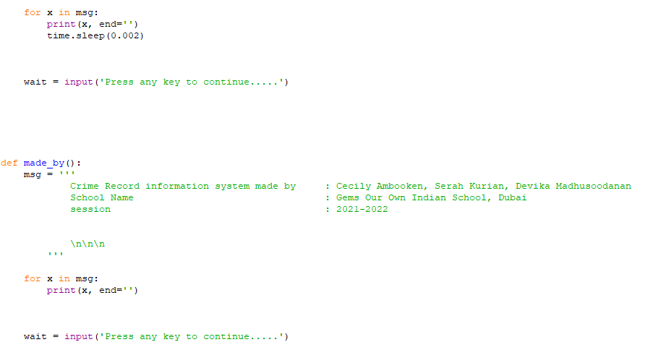

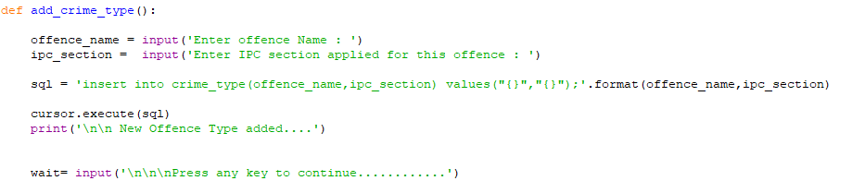

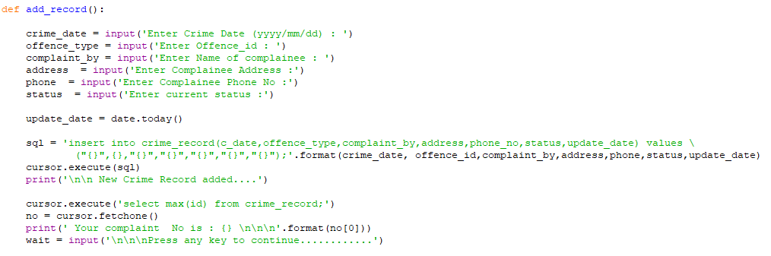

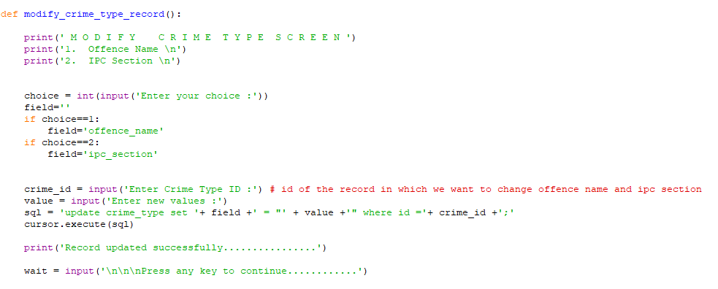

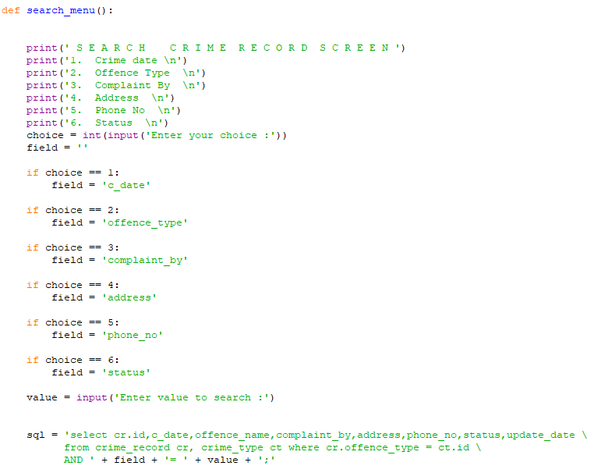

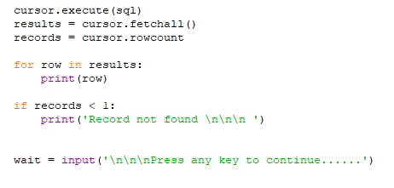

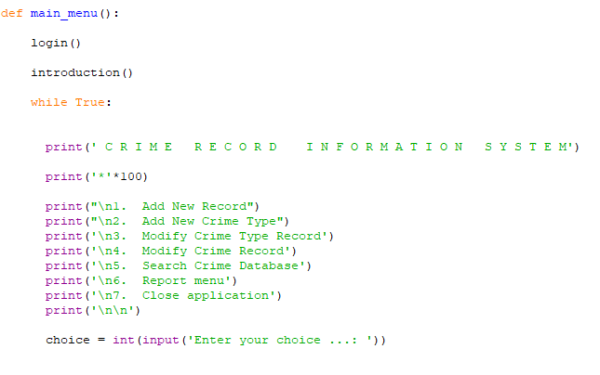

DATABASE



Creating table ‘crime_record’

Output:

Create table ‘crime_type’  
  
Table:

Login  
